**BURPSUITE INTRUDER:**

Burp Suite's "Intruder" tool is a powerful feature designed for automated testing and manipulation of a large number of HTTP requests. It's particularly useful for tasks like fuzzing, brute-force attacks, and automated vulnerability scanning in web applications. Here's an overview of what Burp Suite's Intruder tool can do:

1. Fuzzing: The primary use of the Intruder tool is to perform fuzzing, where it sends multiple similar HTTP requests with various payloads to a target. These payloads are systematically generated, allowing you to test for vulnerabilities or weaknesses in the application's handling of input data. For example, you can test for SQL injection, XSS, or other injection vulnerabilities.

2. Parameter Testing: Intruder allows you to specify which parameters in a request should be tested with different payloads. For instance, you can target specific URL parameters, form fields, or headers.

3. Payloads: You can use various types of payloads in your tests, such as lists of values, character sets, numbers, dates, or even custom payloads. Burp Suite provides built-in payload lists for common security testing scenarios.

5. Attack Types: Intruder supports different attack types, including Sniper, Battering Ram, Pitchfork, and Cluster Bomb, each of which defines how payloads are injected into requests. These attack types provide flexibility in how you test and fuzz different parts of the request.

6. Attack Configuration: Intruder lets you configure how the attacks are conducted, including the number of concurrent threads, the delay between requests, and other parameters to control the attack speed and intensity.

7. Automatic Analysis: After an Intruder attack, you can automatically analyze the responses for anomalies, such as error messages or other indicators of potential vulnerabilities.

8. Reporting: Burp Suite provides detailed reports on the results of the Intruder attacks, making it easy to identify and prioritize vulnerabilities.

The Intruder tool is invaluable for identifying security vulnerabilities, especially those related to input validation and data manipulation. It's a staple tool in the arsenal of security professionals and ethical hackers for web application security testing. However, please use it responsibly, and ensure that you have proper authorization before testing any web application.

**BURPSUITE INTRUDERS TYPES**

**SNIPER ATTACK:** The Sniper attack type is the most straightforward and is commonly used for targeting a single position in the request with a set of payloads. It sequentially inserts each payload into the specified position and sends one request per payload.

Use Case: Sniper is useful for testing individual parameters or fields for vulnerabilities, such as SQL injection or XSS, to see which payloads trigger a response change.

Website: testphp.vulnhub.com

Pass the credentials : jonny & jonny.

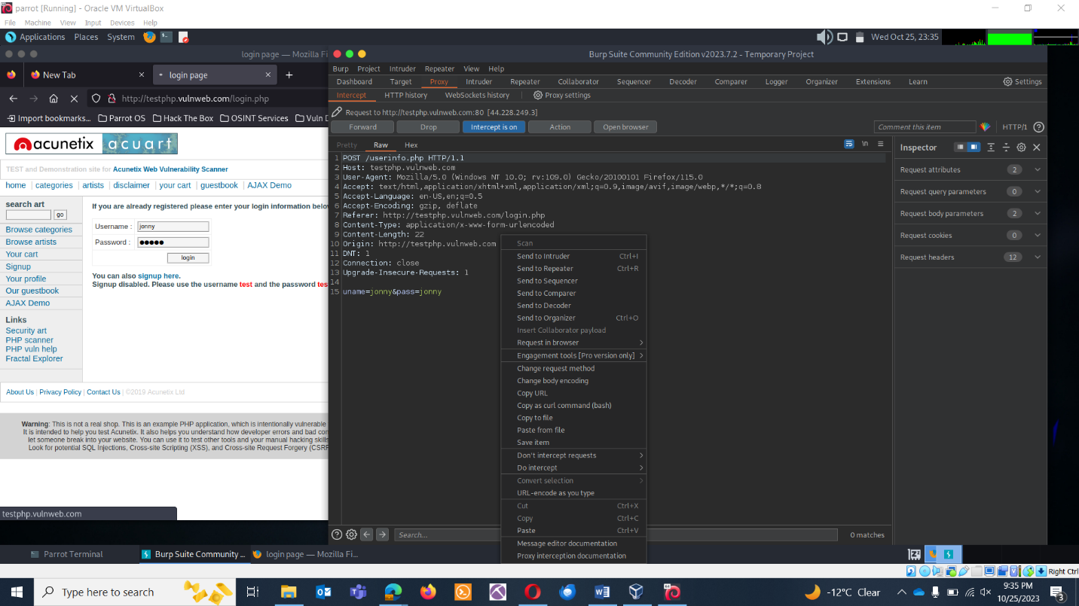

Logins failed.

Select the password field and click on the button add on right hand side.

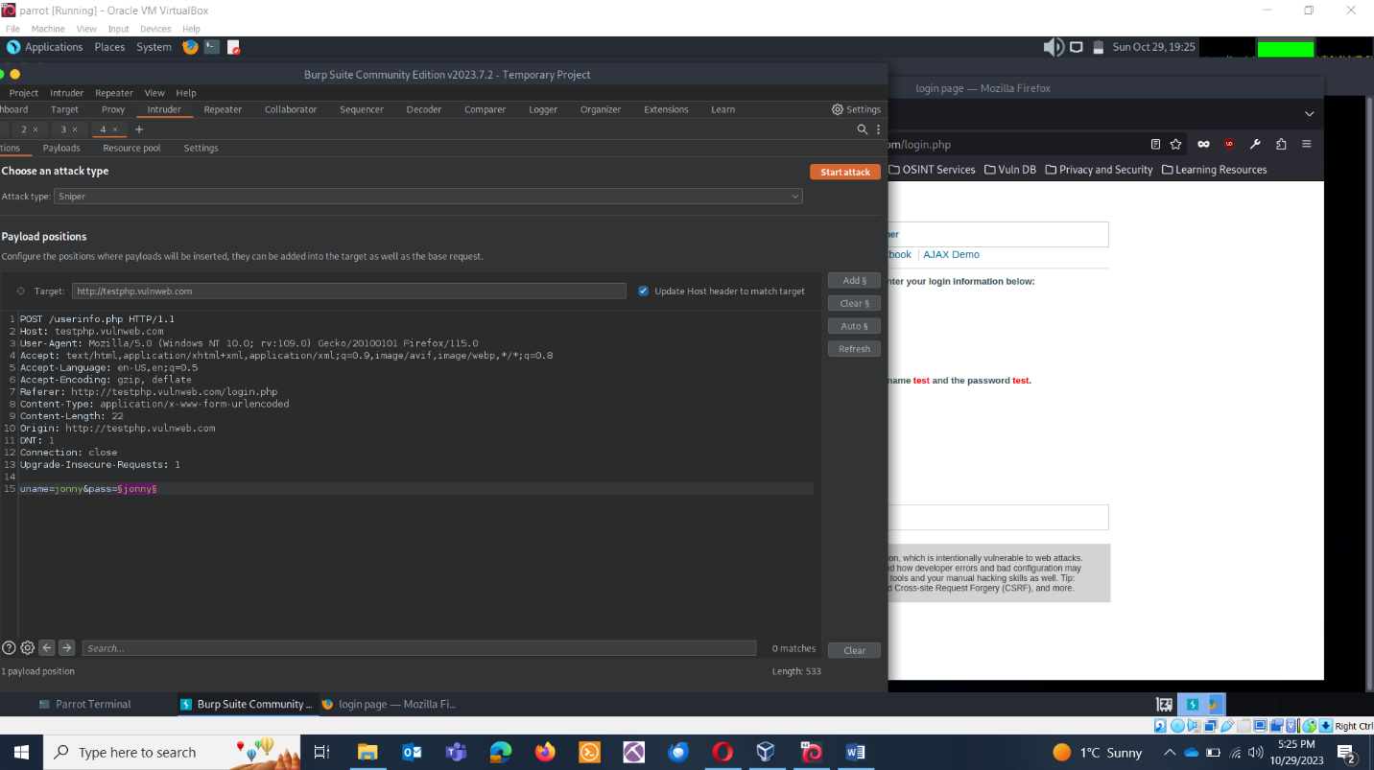

Change the credentials :

Admin: test

Password: jonny

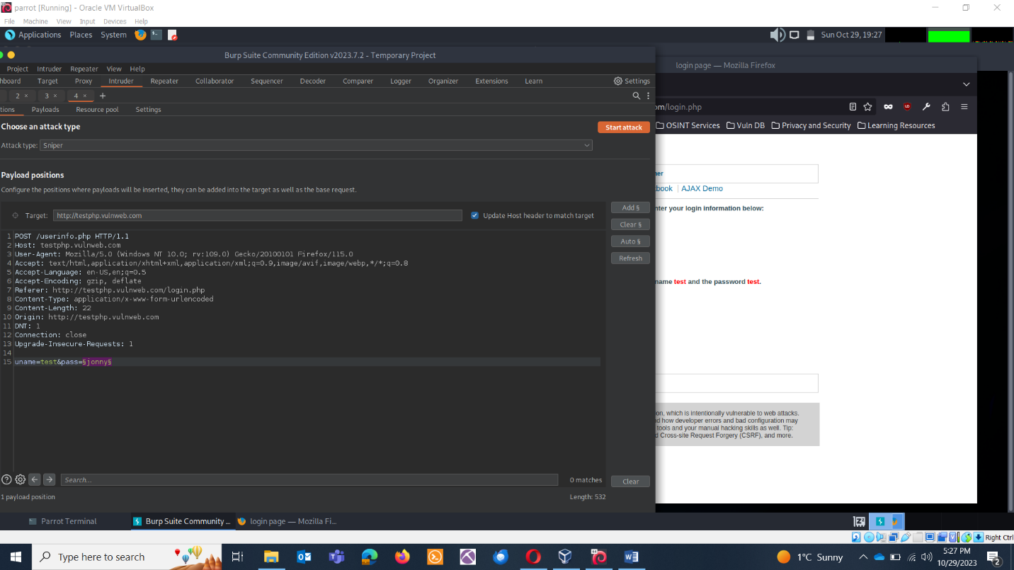

The selected field will be tested against the wordlist.

Click on the payloads and click on load, load your wordlist:

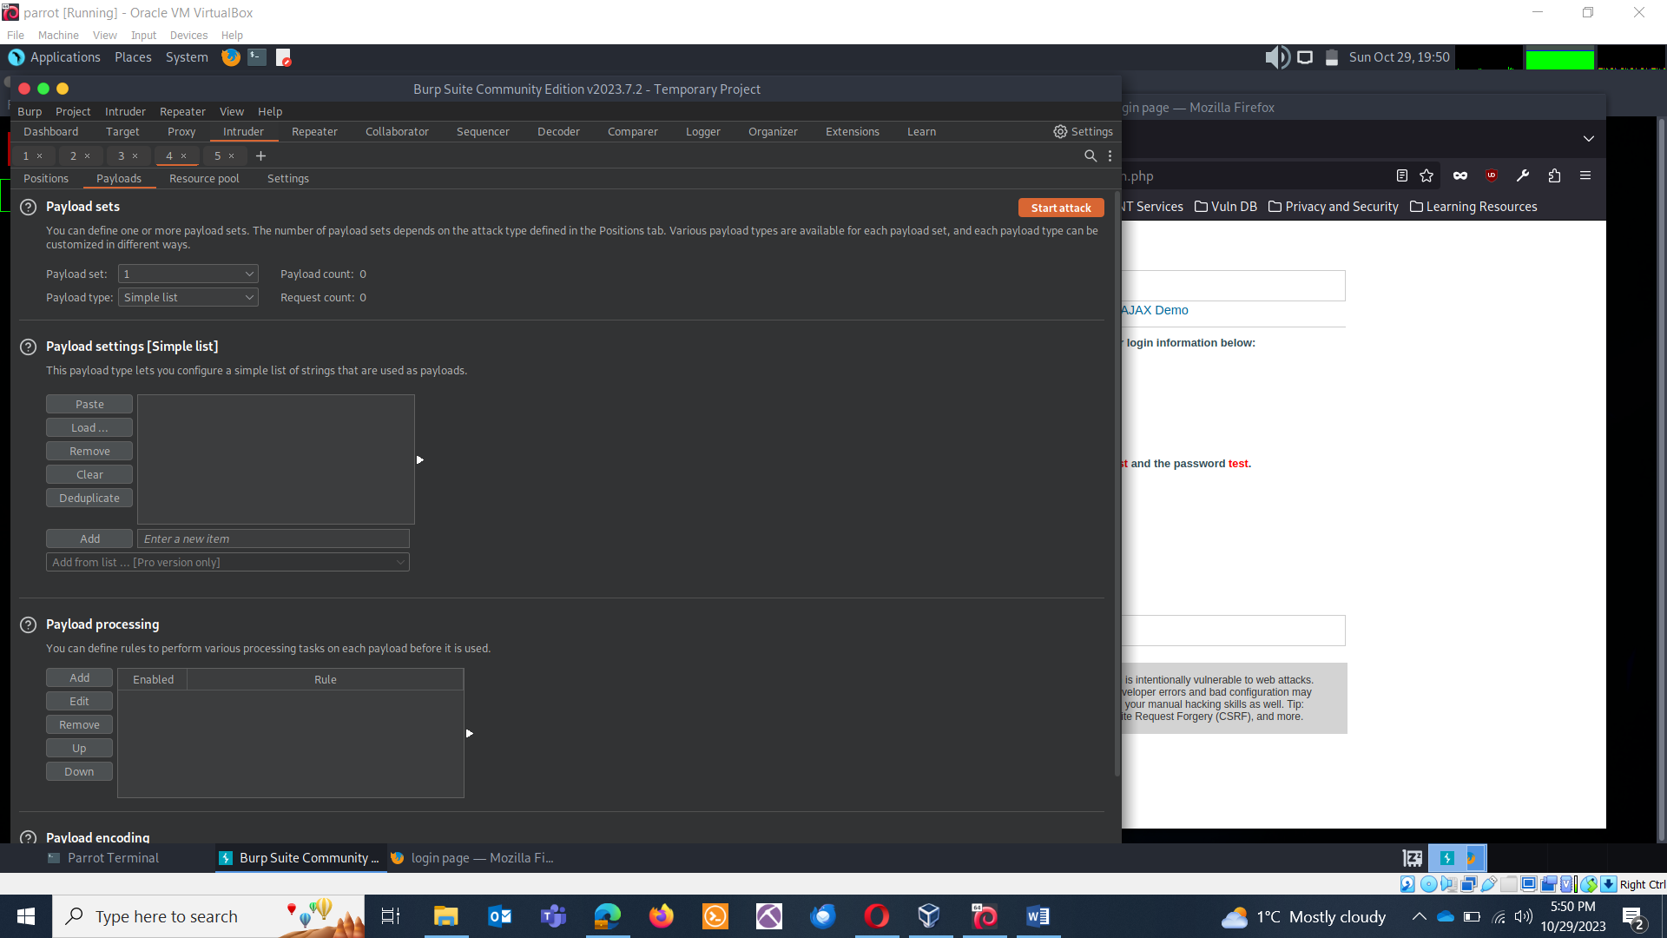

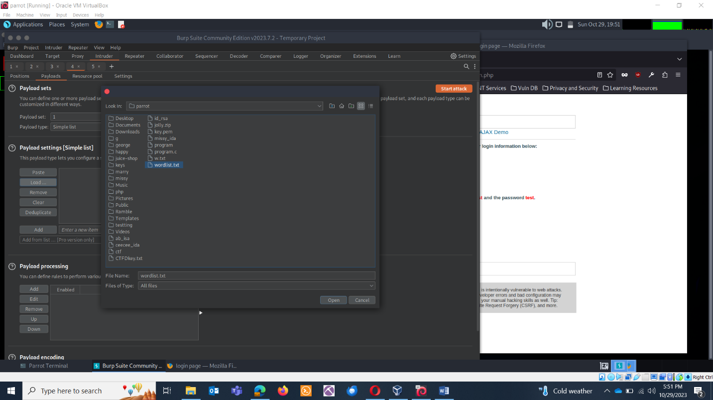

Click on start attack

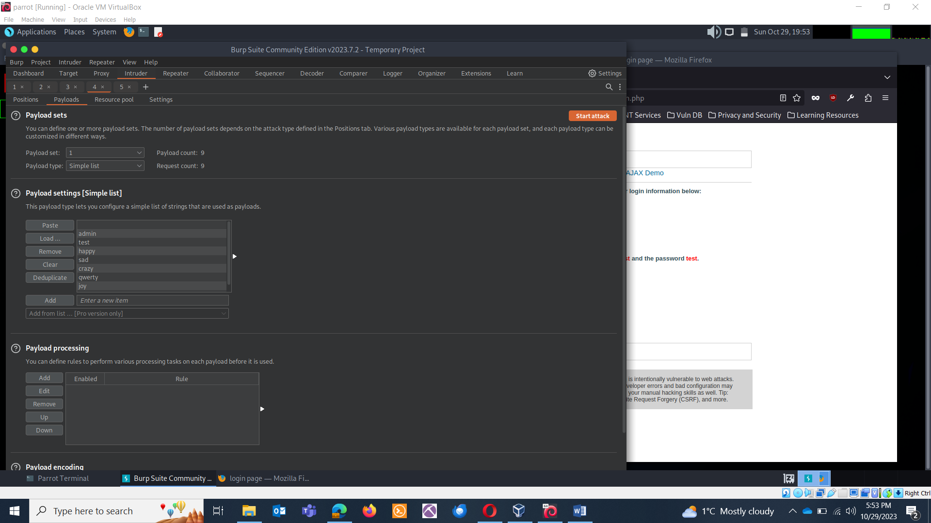

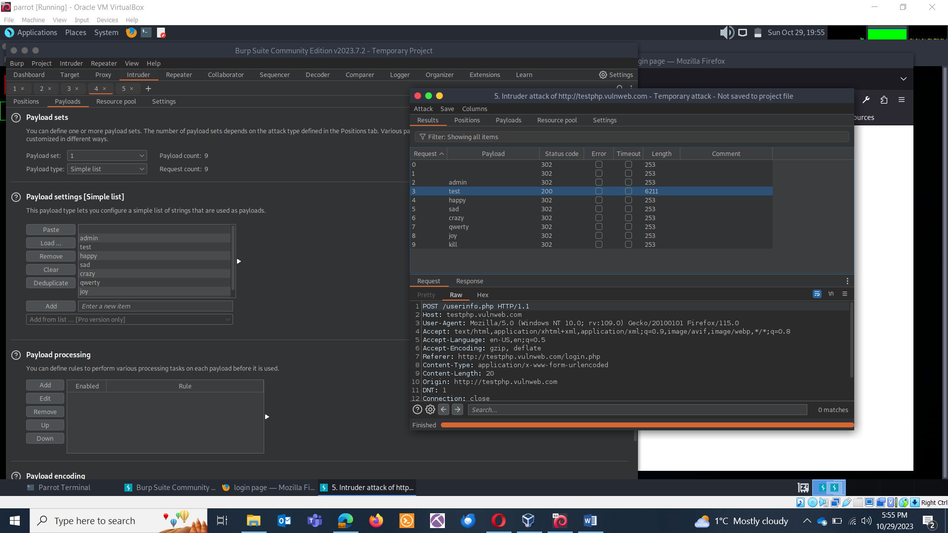

The word with 200 code is the correct answer. We attacked against the password field. This means, one of the user is having a password: test.

**BATTERING RAM ATTACK:** The Battering Ram attack type is used for simultaneously testing multiple positions with the same set of payloads. It sends one request for each payload but repeats the process for all selected positions before moving to the next payload.

Use Case: Battering Ram is handy when you want to test multiple parameters or fields in a request with the same set of payloads. It can help identify vulnerabilities across various parts of the request.

Credentials: admin & admin

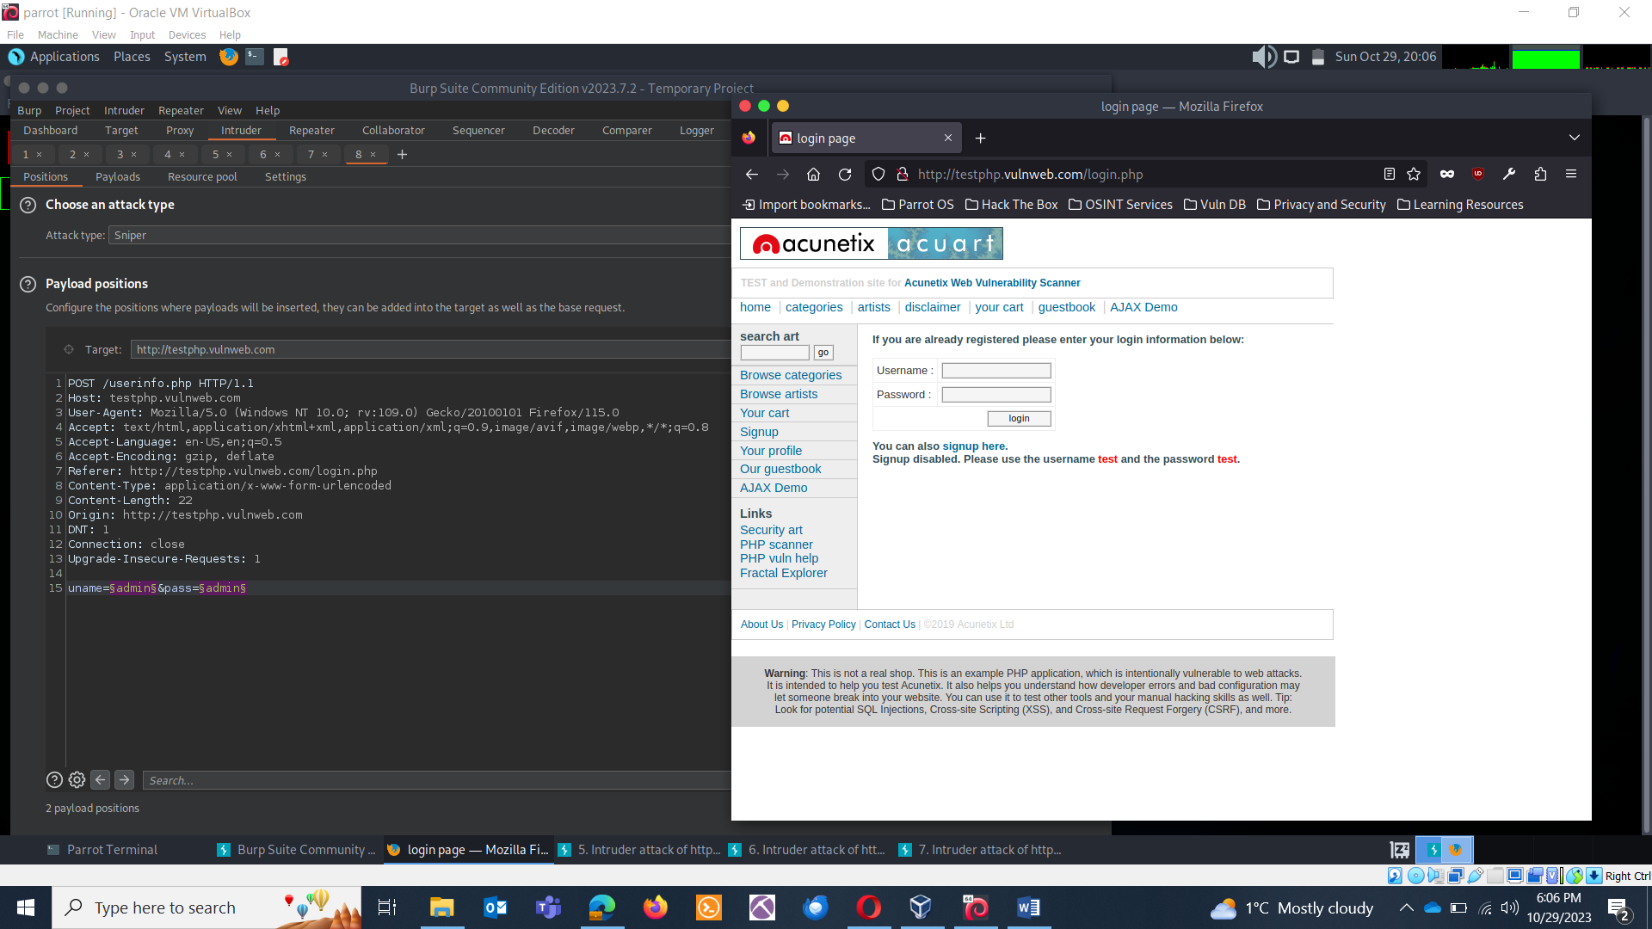

Add admin & password field against attacking fields.

Select the battering Ram attack.

Select your word list.

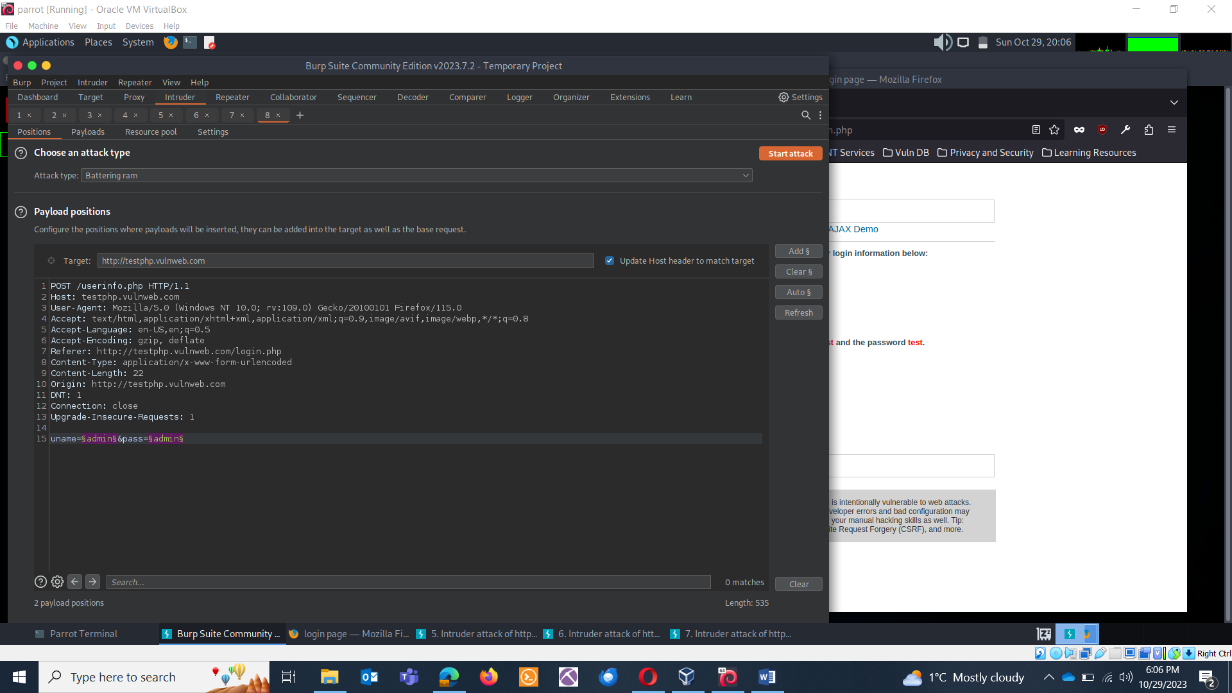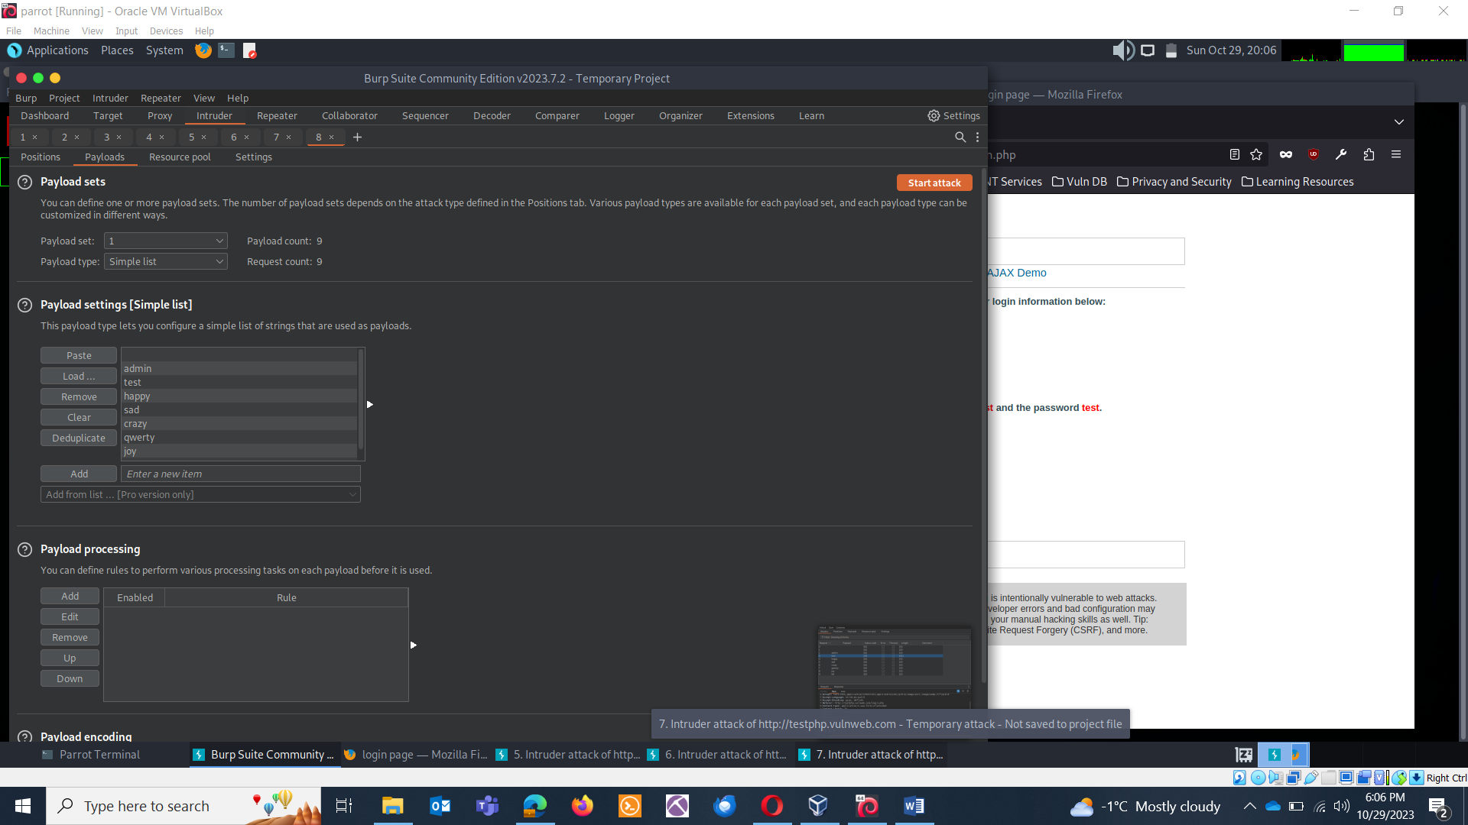

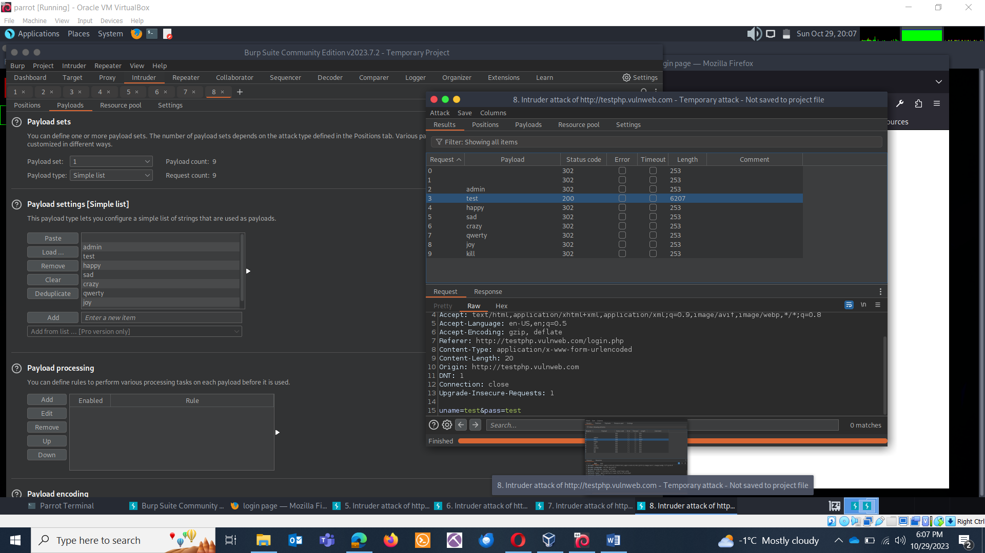

**PITCHFORK ATTACK:** The Pitchfork attack type is used for testing multiple positions with different payloads. It combines payloads from multiple payload sets to create permutations and sends one request per permutation.

Use Case: Pitchfork is useful when you need to test different parameters or fields with various payloads. For example, you might want to test a login form where the username and password fields require different payloads.

Select Pitchfork. Select both fields. 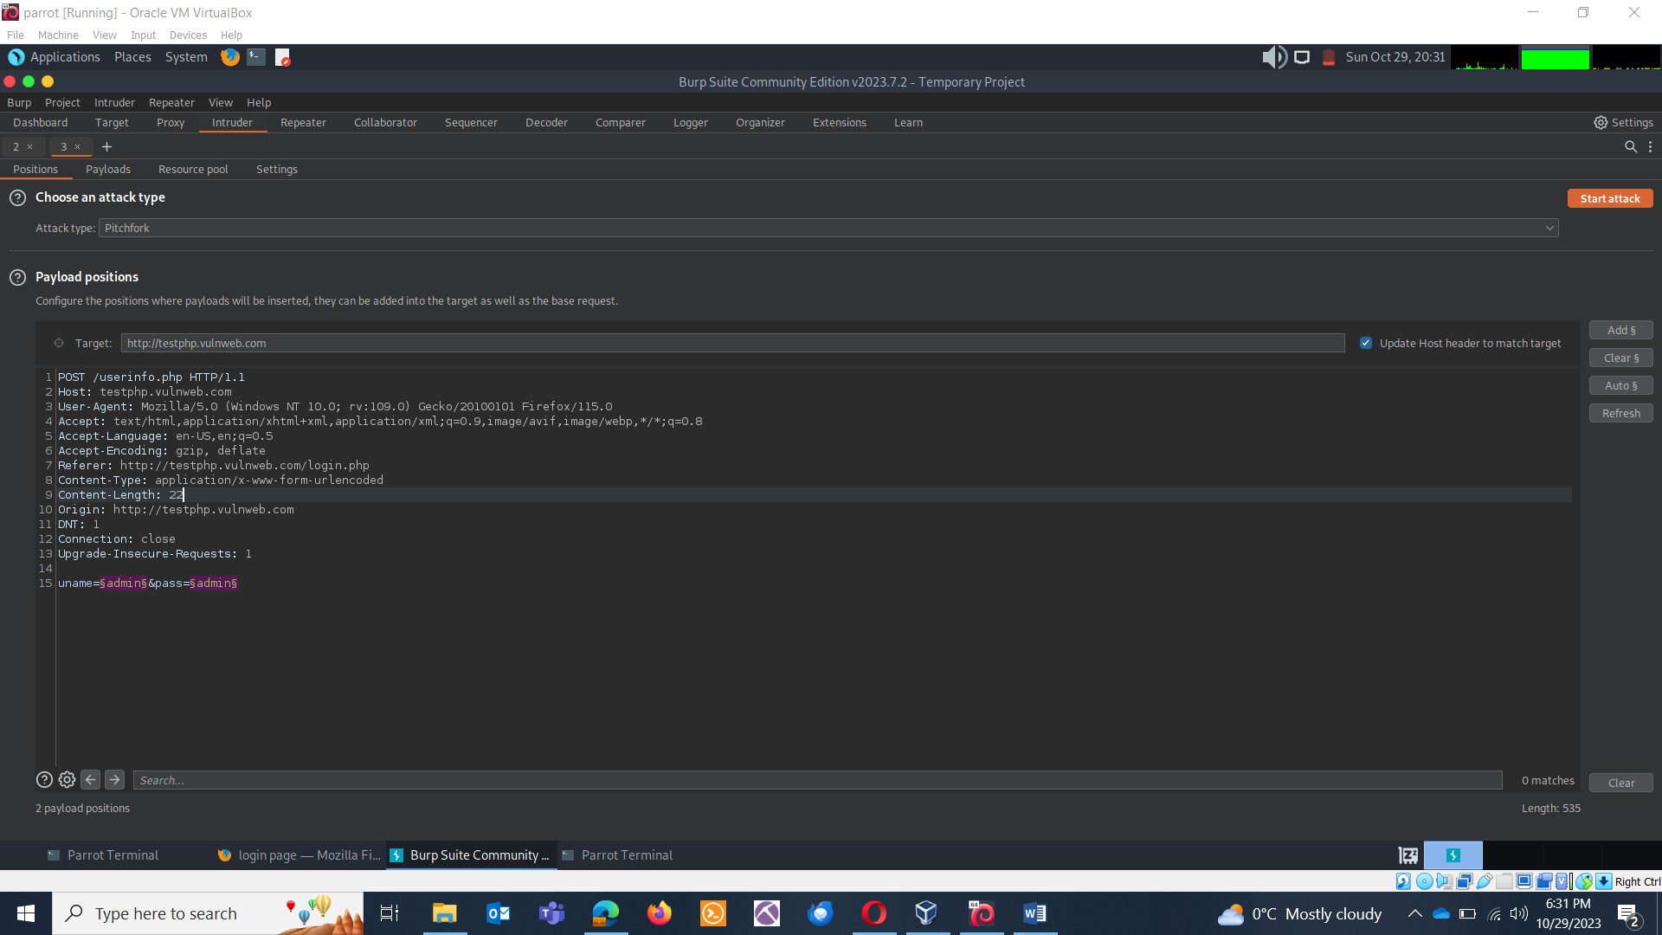

You’ll have to load two payloads.

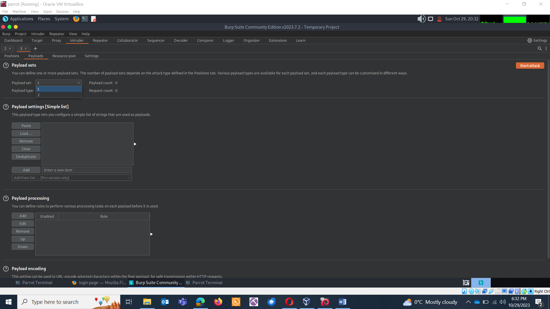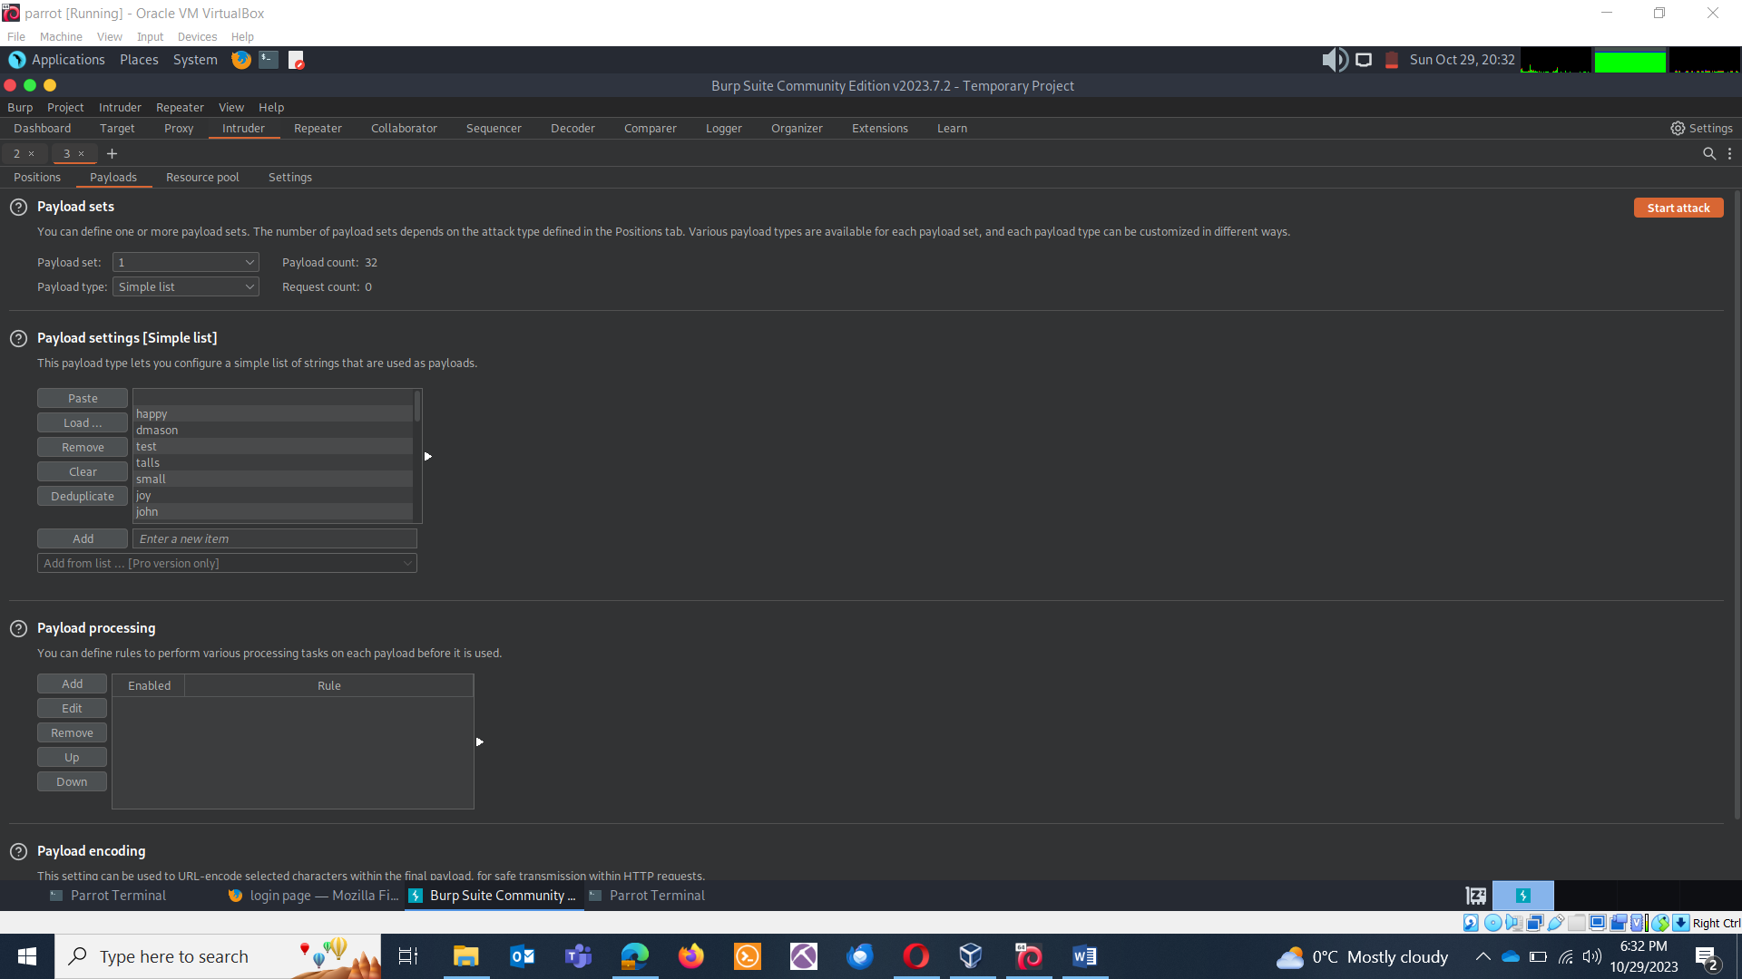

Loading Payload 2: 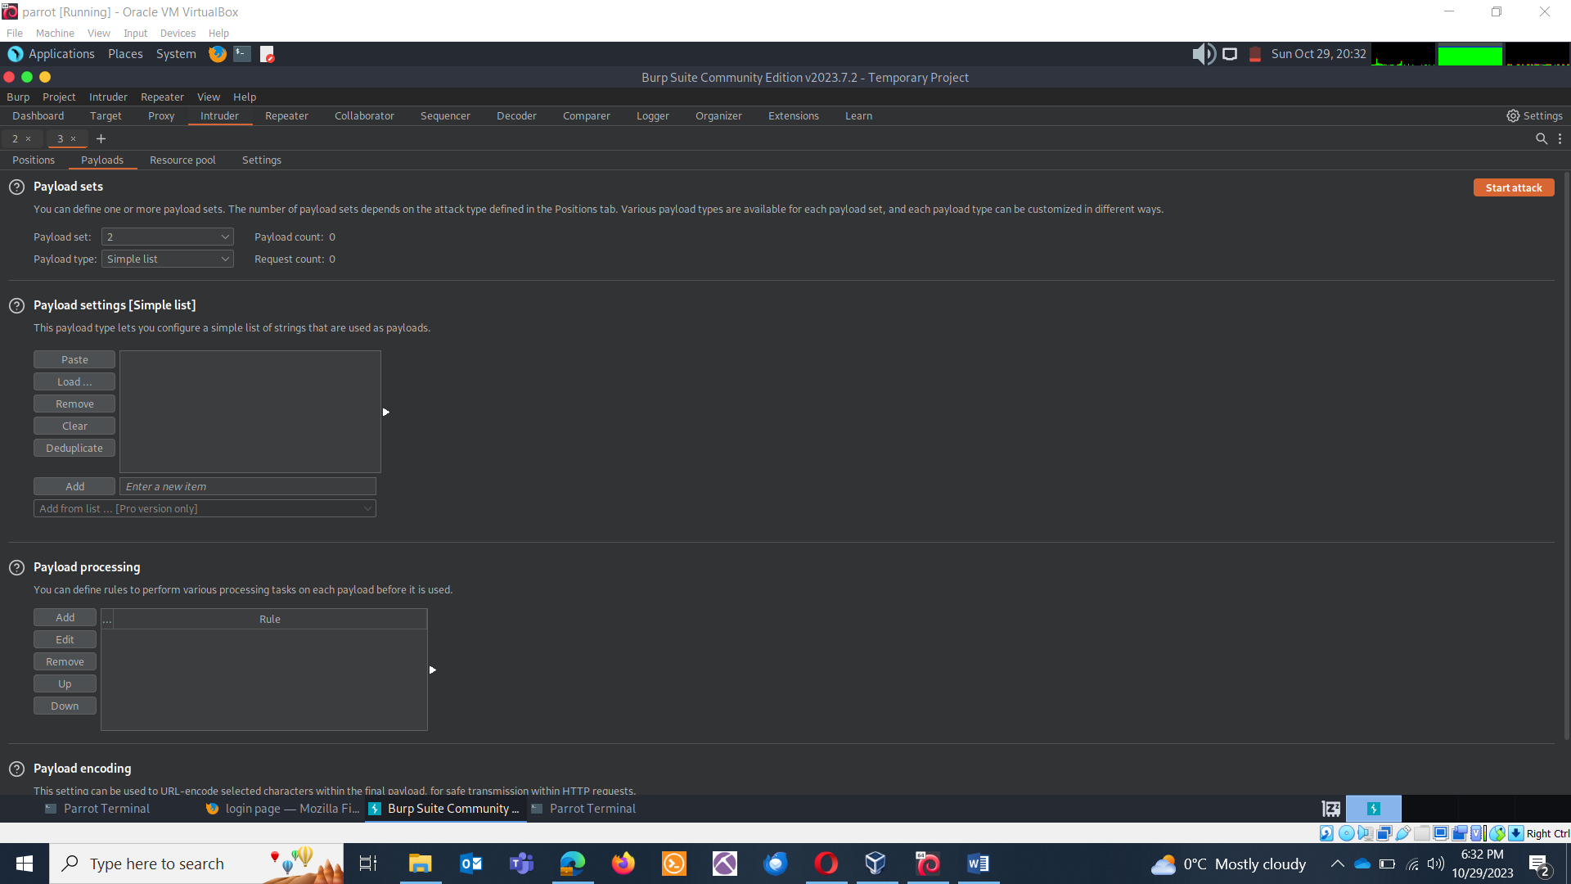

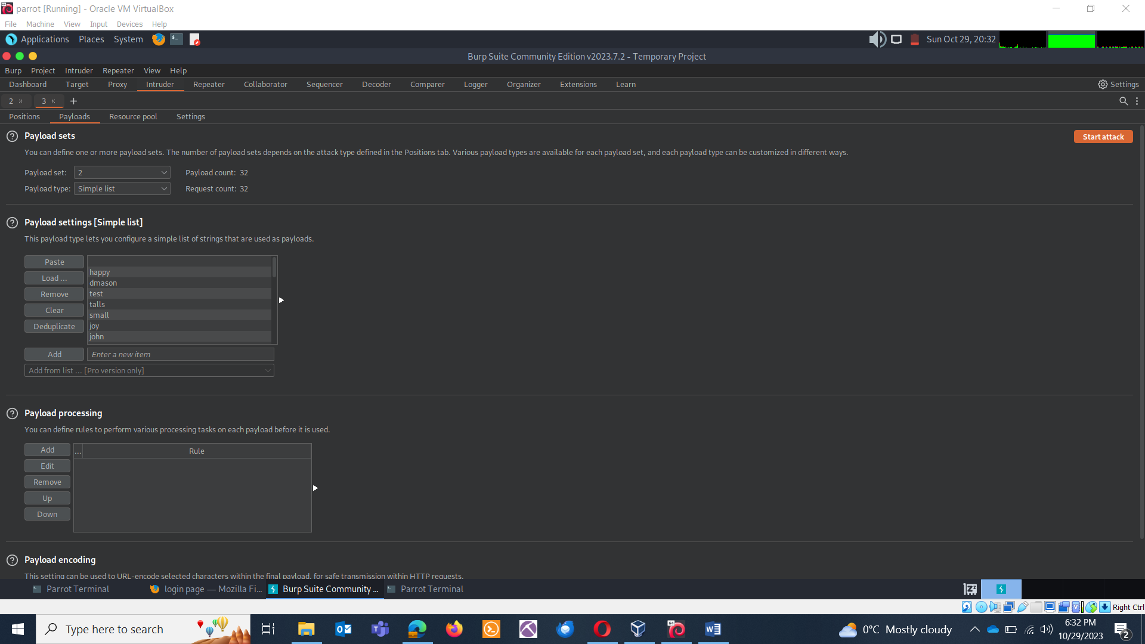

Start attack:

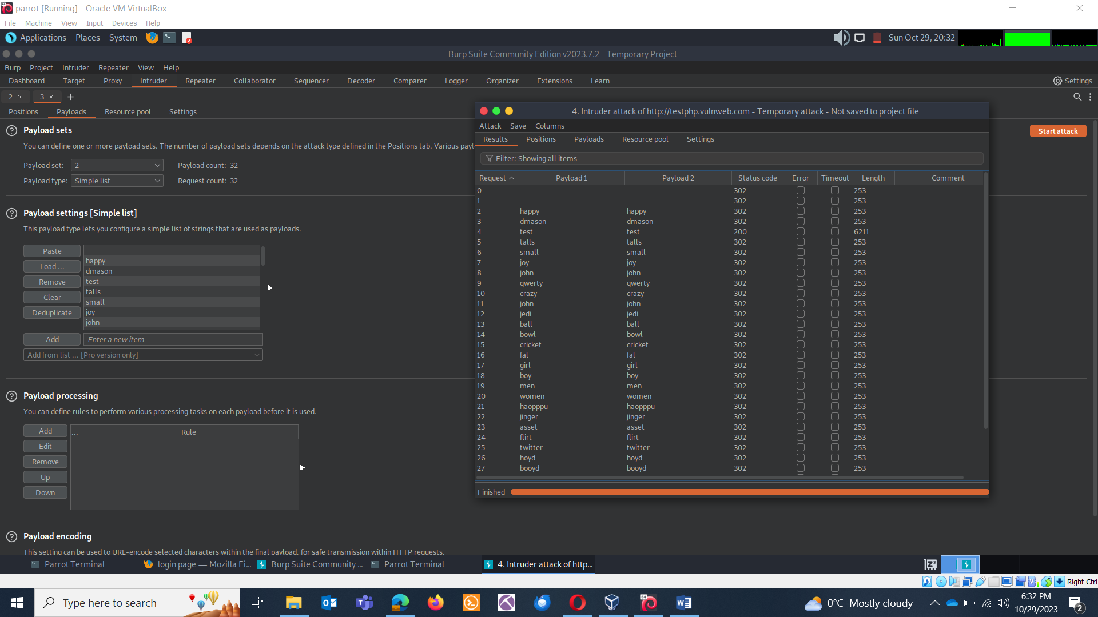

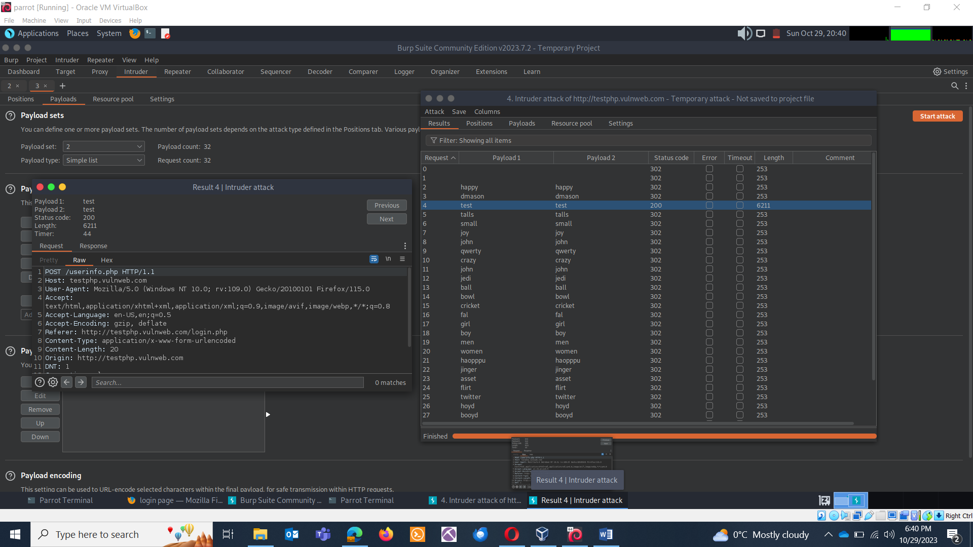

**CLUSTER BOMB ATTACK:** The Cluster Bomb attack type is used for testing multiple positions with different payloads. It combines payloads from multiple payload sets to create combinations and sends one request per combination.

Use Case: Cluster Bomb is helpful when you need to test different parameters or fields with various payloads. It's similar to Pitchfork but focuses on combinations of payloads rather than permutations. This can be useful for complex test cases.

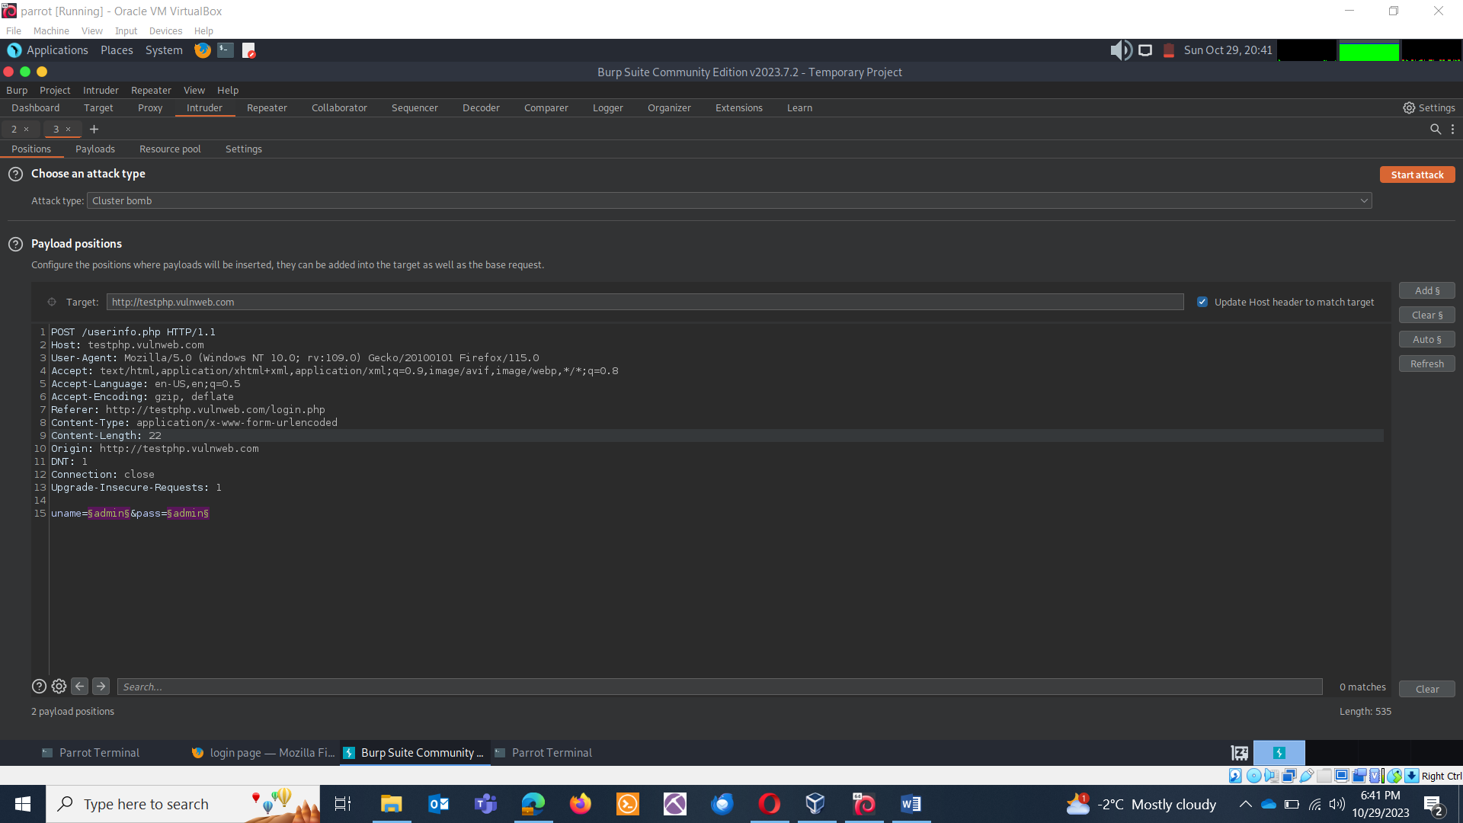

Repeat same procedure as Pitchfork.

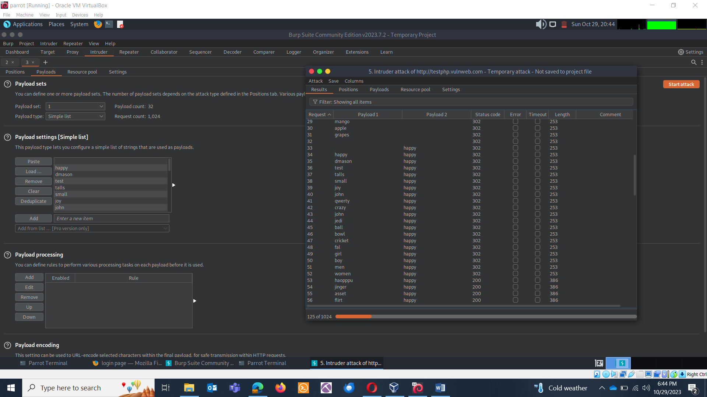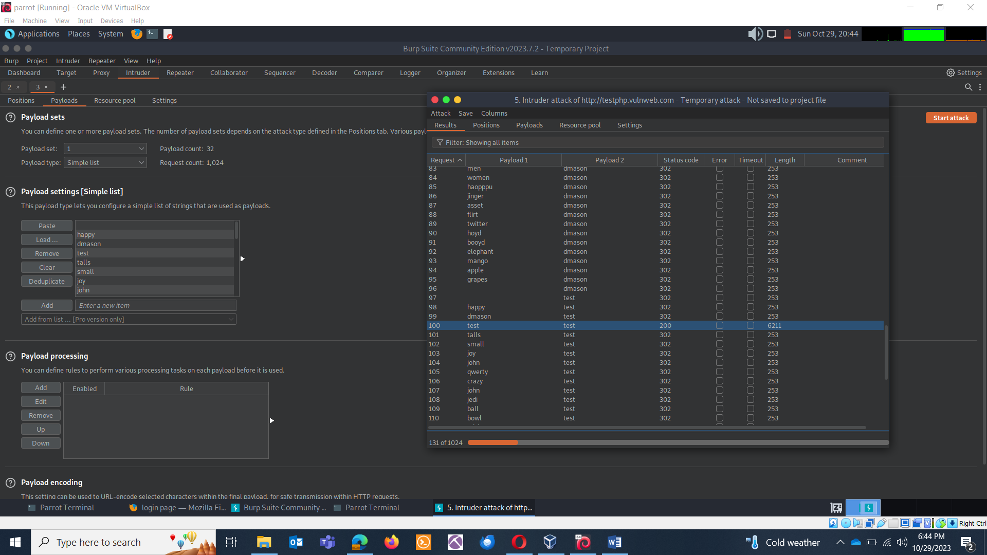

BURPSUITE DECODER

Burp Suite Decoder is a tool within Burp Suite Professional designed to decode and encode various data formats and encodings. It's a handy utility for security professionals and developers to manipulate data during web application testing or development. Here's how to use Burp Suite Decoder and some of the common tasks it can assist with:

How to Use Burp Suite Decoder:

Launch Burp Suite: Start Burp Suite Professional and make sure it's configured for your web application testing.

Open Decoder: Click on the "Decoder" tab in Burp Suite. You'll find four main tabs within Decoder: "Decode," "Encode," and "Hash”.

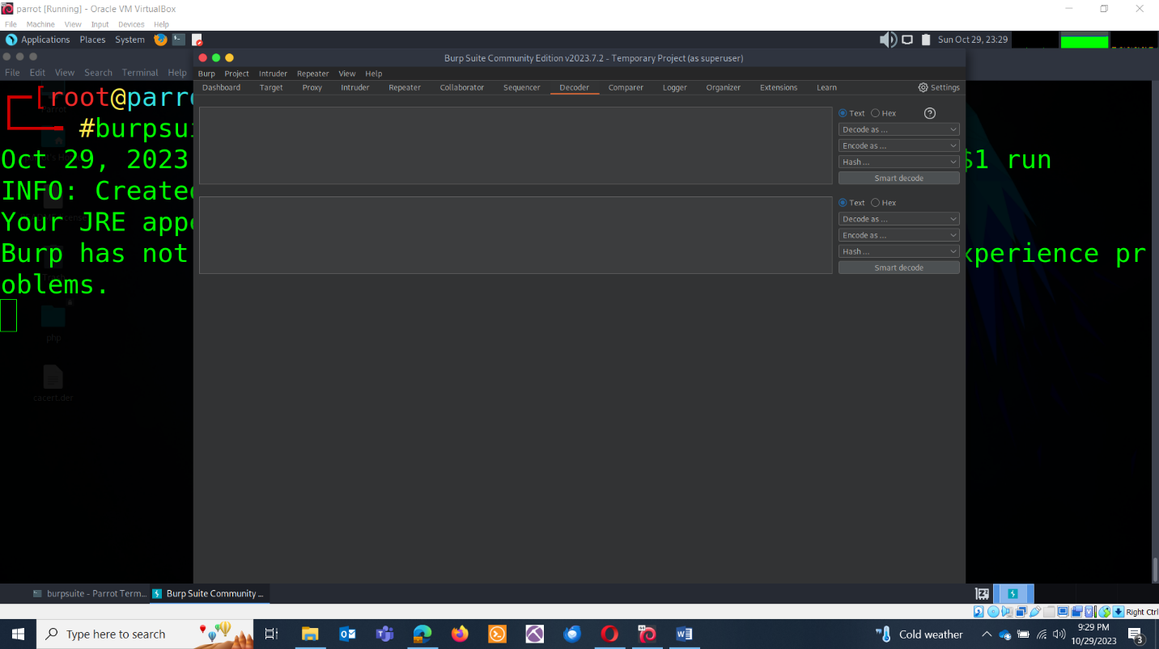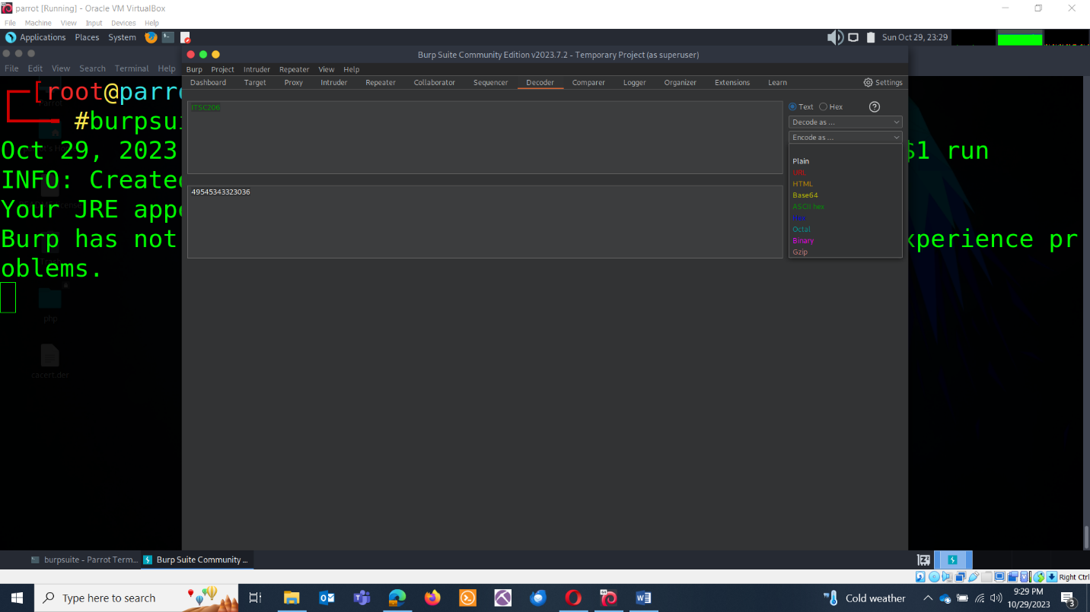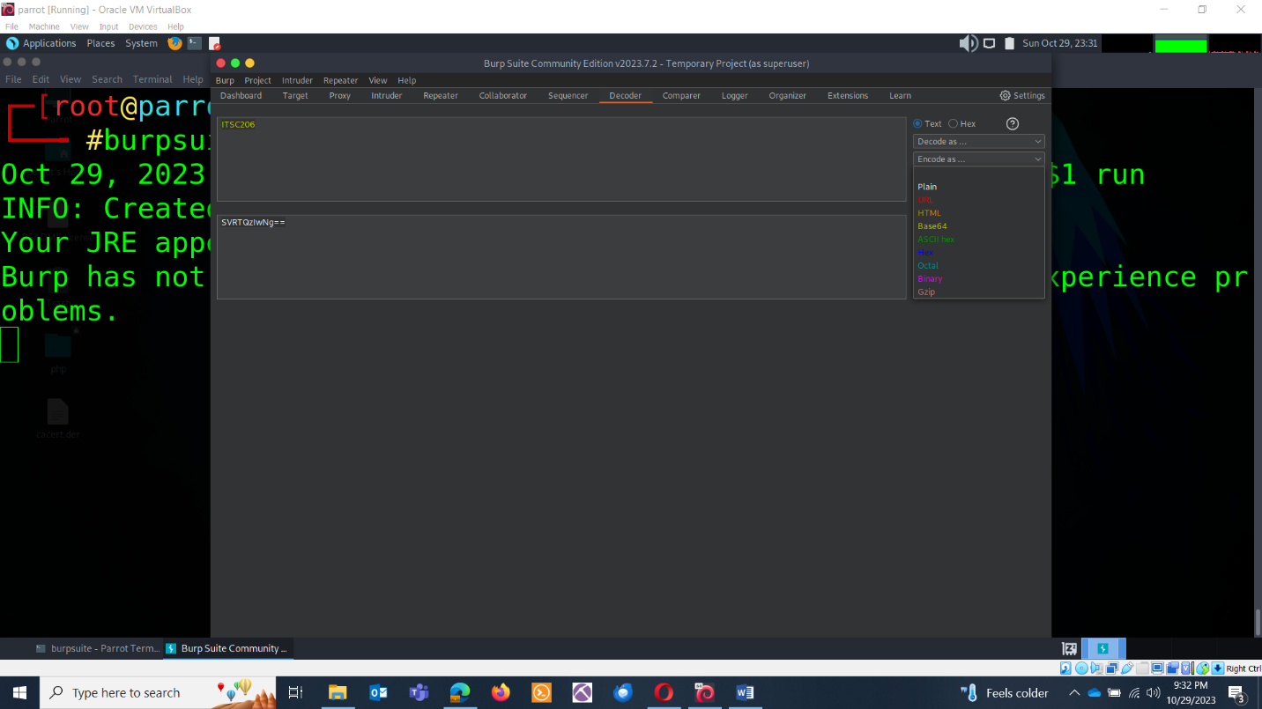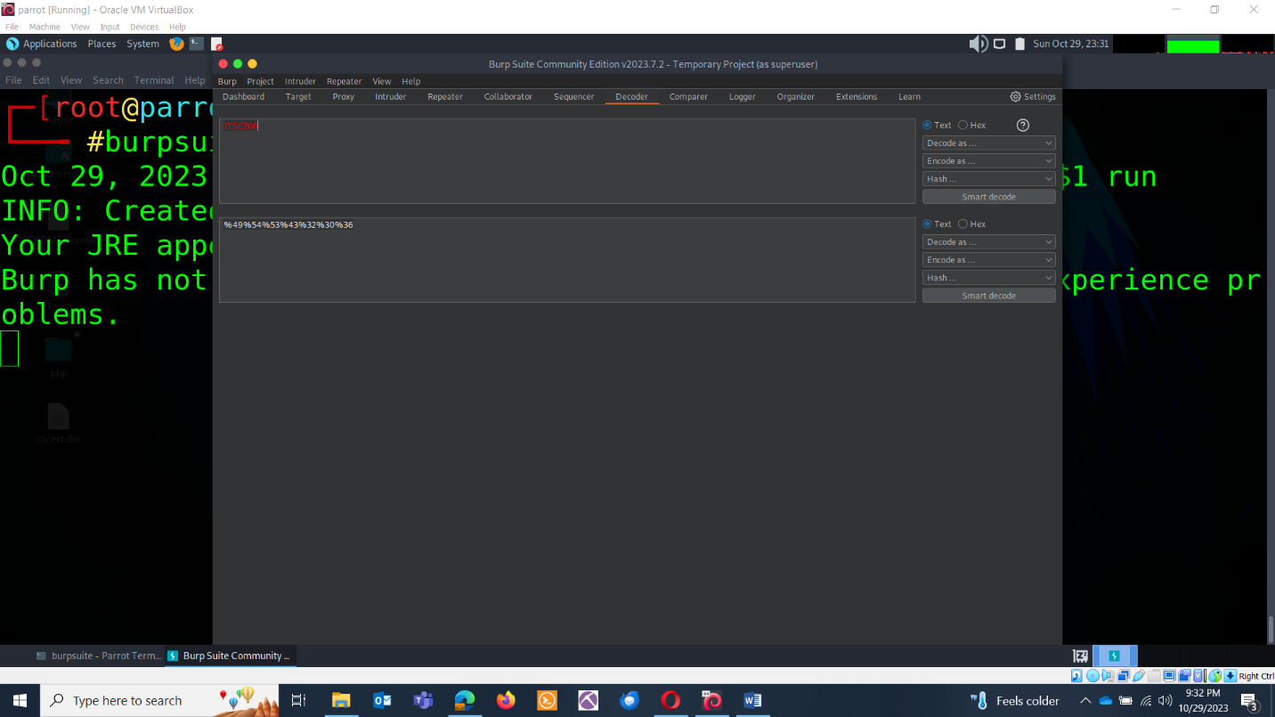

BURPSUITE SEQUENCER:

Burp Suite Sequencer is a tool designed to analyze the quality of randomness and entropy in data, often used for assessing the security of tokens, session identifiers, and other sensitive information in web applications. It helps security professionals identify weak or predictable values that could be exploited by attackers.

**RANDOMNESS**: Randomness refers to the degree of unpredictability or lack of pattern in data.

**ENTROPY**: Entropy is a measure of the amount of disorder or randomness in a system. In the context of information theory, it quantifies the uncertainty or surprise associated with the outcome of a random process.

**HOW TO USE BURP SUITE SEQUENCER:**

* Launch Burp Suite
* Capture Data: Intercept and capture the data. Send the data to sequencer.

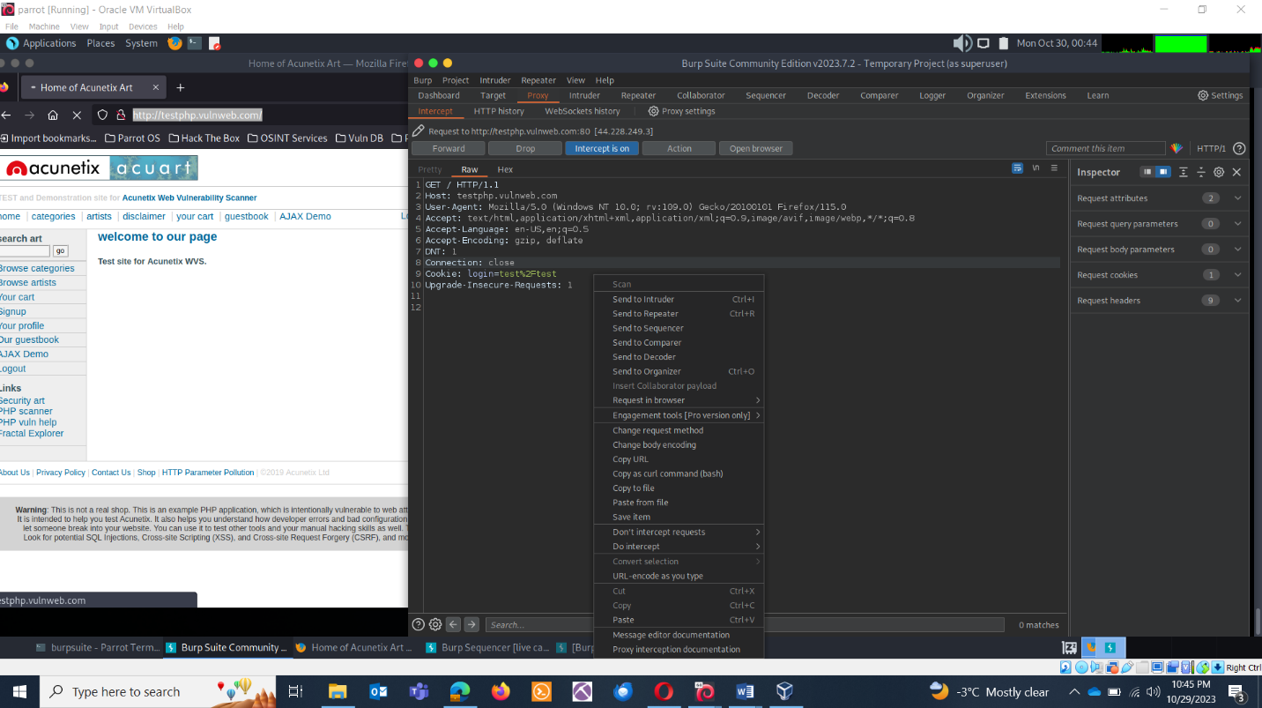

* Configure Sequencer and click on start live capture.

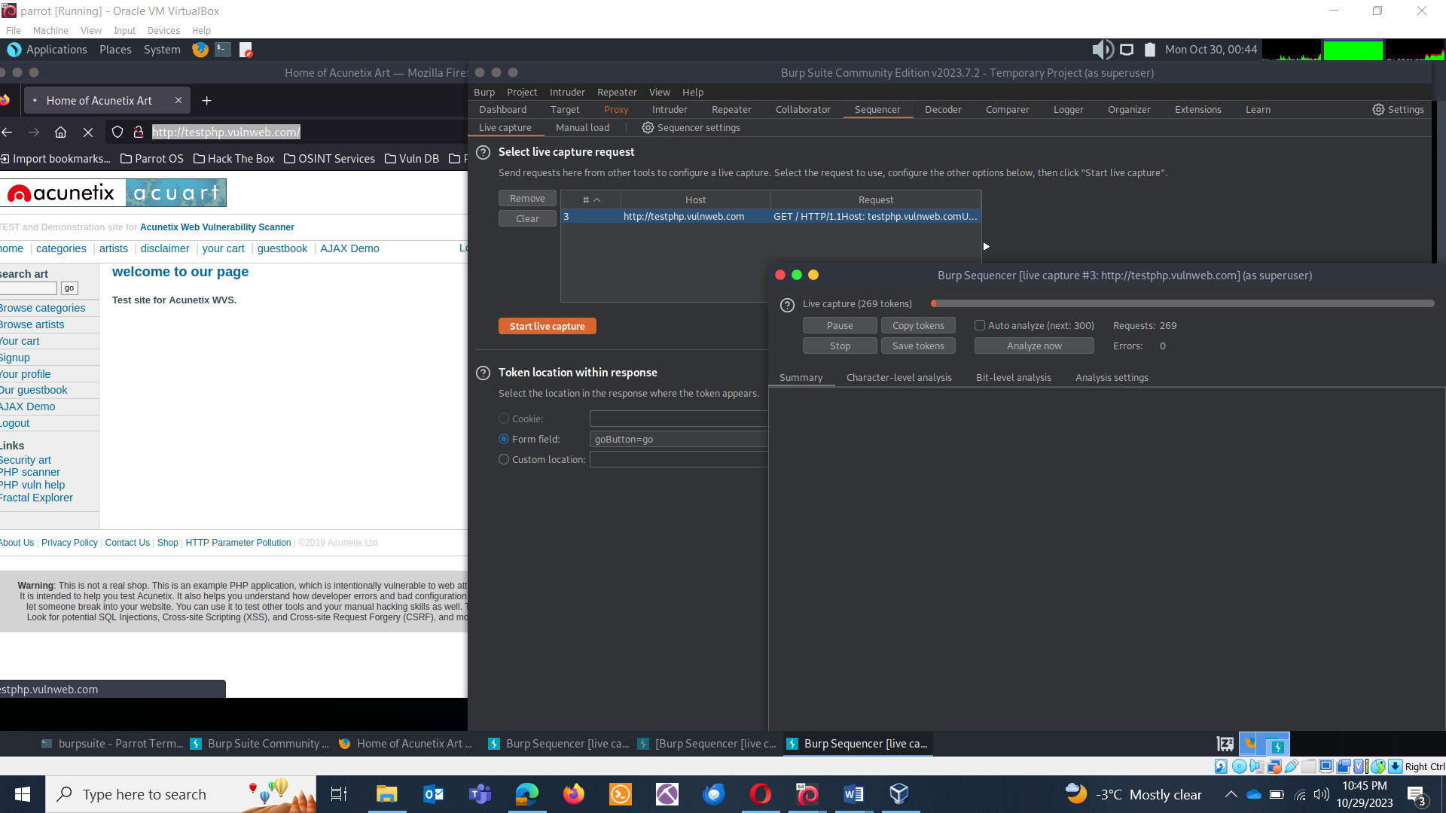

* View Results

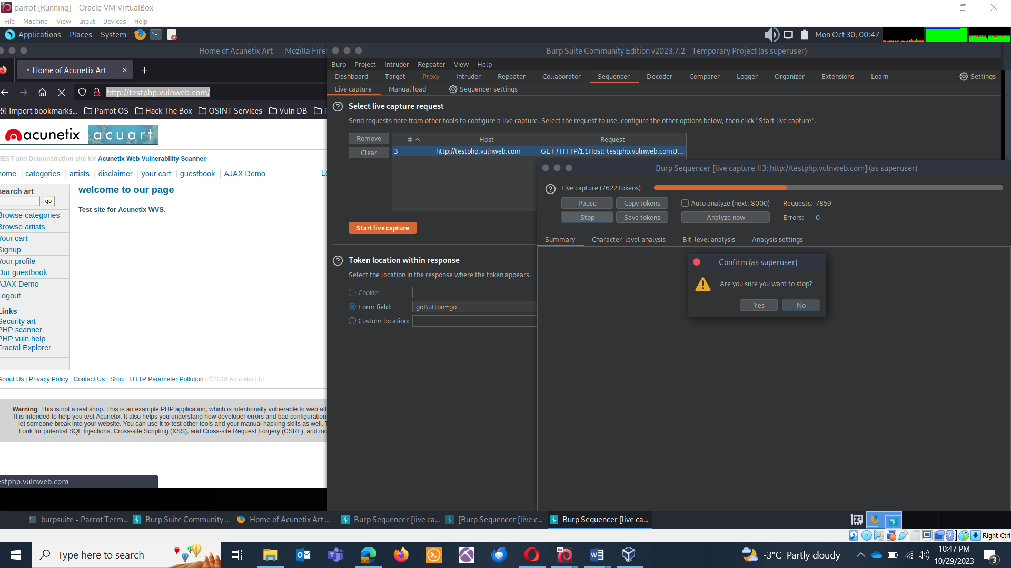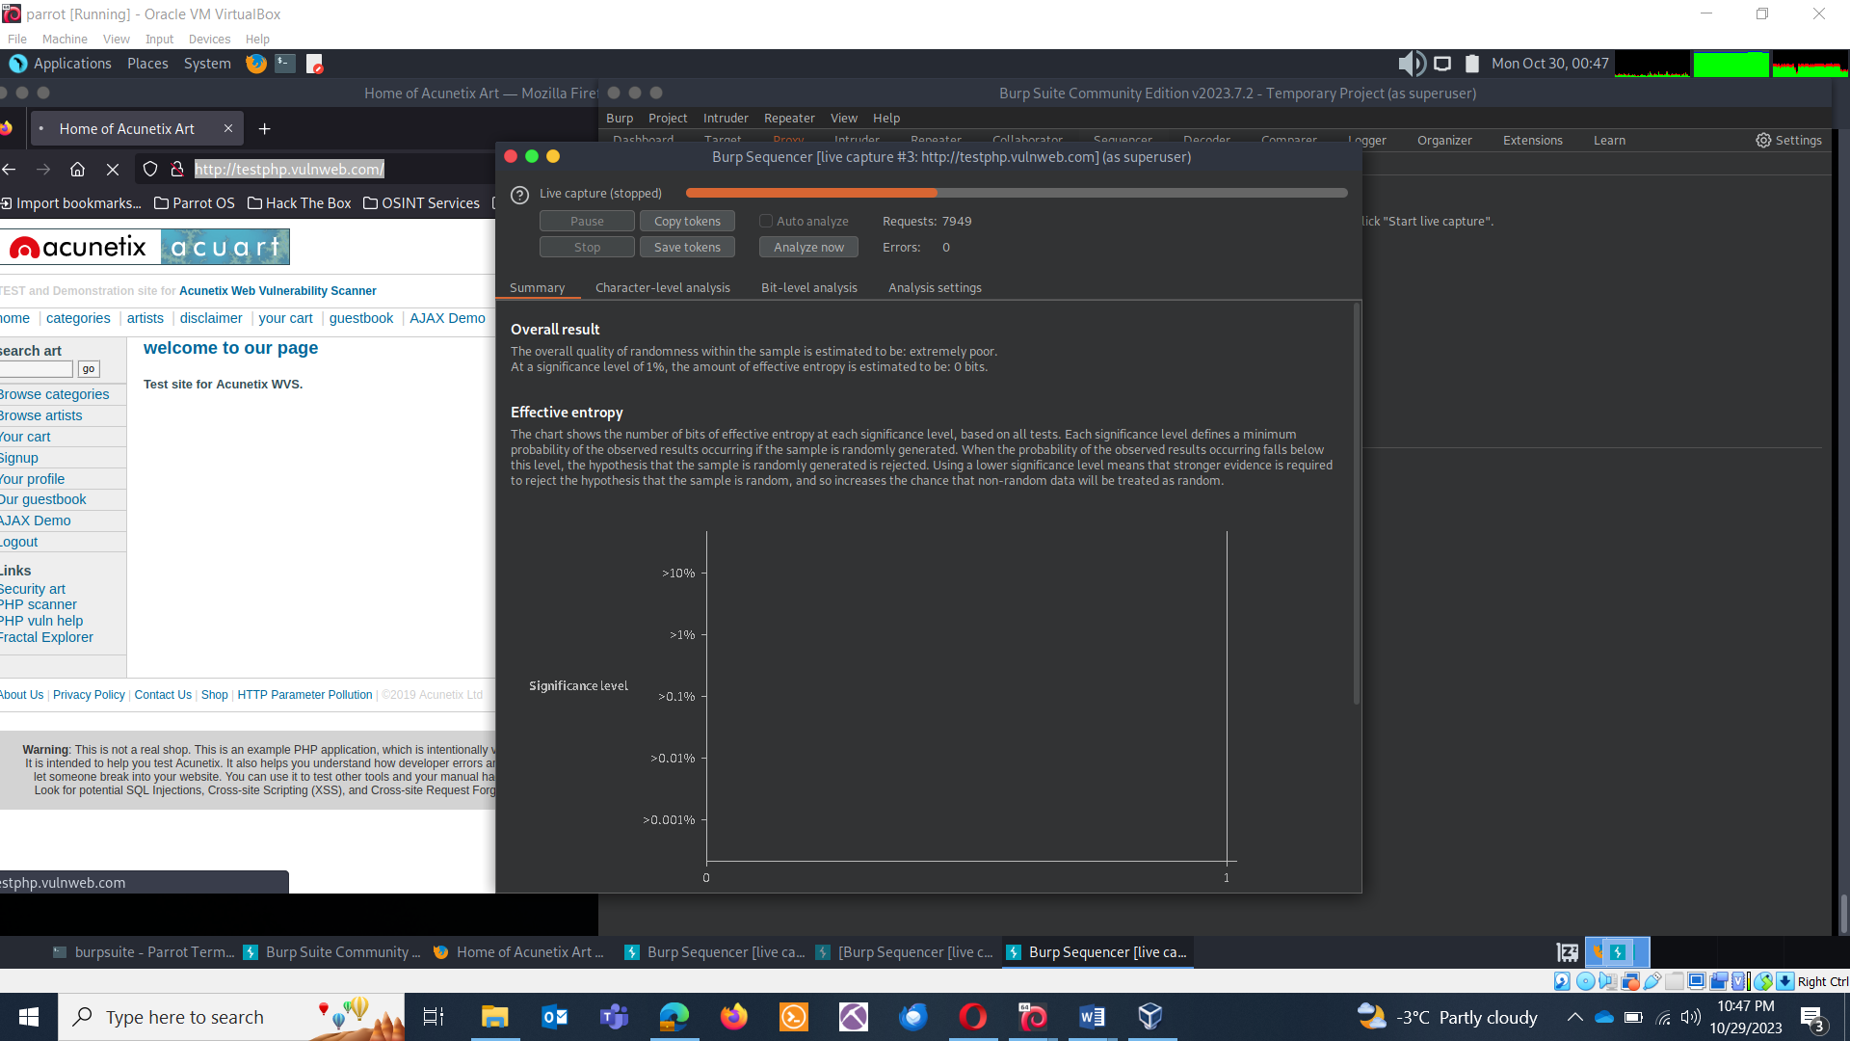

RESULTS ANALYSIS:

